URL : <https://www.youtube.com/watch?v=FL7K2A2KH7g>

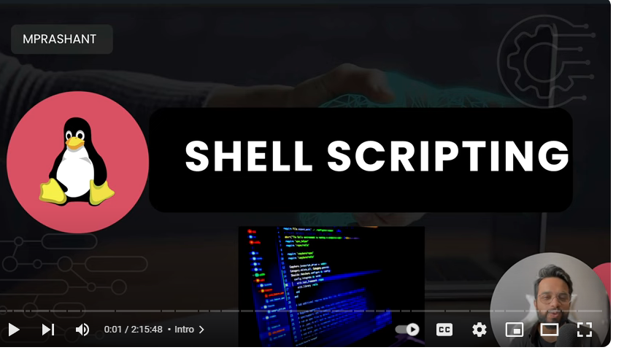

Shell is Like a terminal

How to check diff types of shells available in our machine

In ubuntu

It gives default shell type of OS .

In Mac OS default shell is

What other type of shell available in mac OS

How to change the default shell

Type bash

Now change it to bash

Echo $0

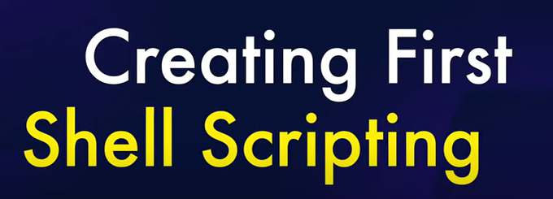

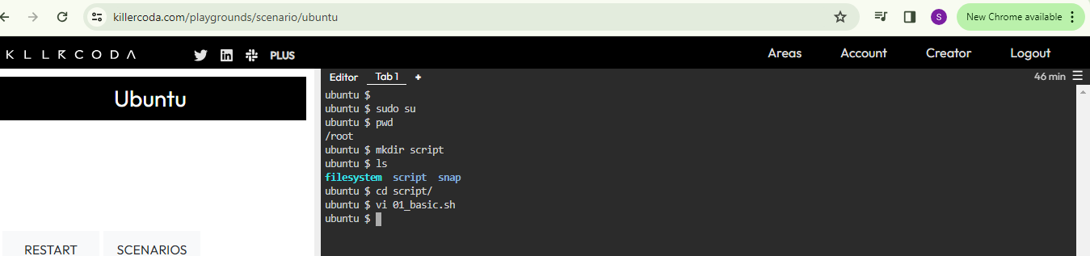

Check ls

How to see the file by cat command

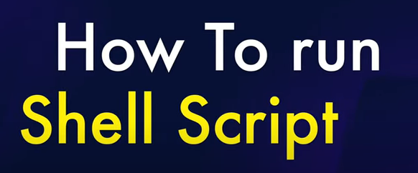

Below is a second method to check the shell script

To run a shell script

Type the comand

:wq for save and exit in Vi editor file



